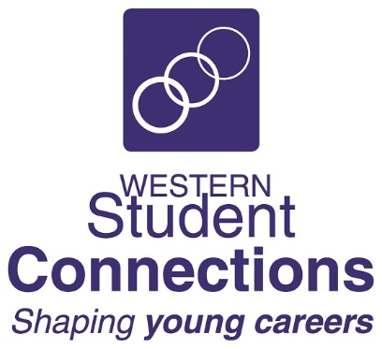 | The Be Real Game Training Days 2022 | 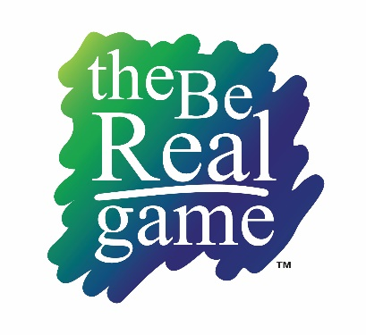

Some may remember The Real Game Series which was introduced in Australia in 2002 with an update in 2005. The Be Real Game is the “game” designed for Year 9 and Year 10 students, with the same wide array of life and work experiences for students using role play and real-world scenarios.

With the assistance of the NSW Department of Education RIEP program and the endorsement of CELLO, the Canadian rights holder, Western Student Connections has upgraded The Be Real Game to include additional occupations, up to date Role Histories and the integration of technology.

The Be Real Game App has been developed to replace the original Spin Game activity and is available for free download for Apple and Android devices.

All resources are available on a secure website including a Facilitator Guide and all student activities.
Students and Teachers are able to log in and access The Be Real Game, with students working through the activities under the guidance of their teacher.

The Be Real Game Training
We will again be running training days for The Be Real Game Online for Careers Advisers, Work Studies teachers, and anyone else who would like to introduce The Be Real Game Online in their schools.

The training will be delivered using Microsoft Teams from 9:30am to 3:00pm.

You will need to have registered as a Facilitator on The Be Real Game web portal and download the Be Real Game App onto your smart phone or tablet/iPad.

https://wsc.edu.au/brg_online.php

9:30am Introductions, log in, and the App
9:45am The Facilitator Guide and other resources, Student Portal
10:00am The Be Real Game Powerpoint Presentation
10:15am Unit One – Brave New World of Work
11:00am – 11:15am Morning Tea Break
11:15am Unit One – continued
12:15pm Unit Two – Agents of Change
1:00pm – 1:30pm Lunch Break
1:30pm Unit Three – Exploring the Future
2:30pm Implementation Discussion
3:00pm Conclusion

A feedback form will be emailed after the workshop.

Ana Pateman

Chief Executive Officer  Western Student Connections  2/12 Blueridge Drive  Dubbo NSW 2830  Ana.Pateman@wsc.edu.au |  | If you require any further information, please contact Beth Beatty:  Beth.Beatty@wsc.edu.au  Ph: 02 6885 6144
 | The Be Real Game Online
2022 Facilitator Training
1. Course Name: | The Be Real Game Online – Facilitator Training
2. Date:
Please tick one
3. Participant Name:
4. Current Workplace:
6. Category: | Careers Adviser Work Studies Teacher Other  If “Other” please specify:__________________________________

Section 2 Personal Details:
7. Preferred Name:
8. Contact Details: | Mobile:
 | Email:
9. Gender: | Male Female
Section 3 Other Information:
10. Are you of Aboriginal or Torres Strait Islander origin? No
Yes, Aboriginal Yes, Torres Strait Islander
11. Do you consider yourself to have a disability, impairment, or long-term condition? No Yes
If yes, mark any applicable box:
Vision Hearing / Deaf Physical Intellectual Medical Condition Mental Illness
Acquired Brain Impairment Learning Other: __________________________________
12. Do you require assistance because of this disability, impairment or long-term condition? No Yes
If Yes, please contact Western Student Connections
Section 4 Declaration:
I understand that this workshop is delivered by Microsoft Teams and I will receive a Teams invitation via email shortly after receipt of this form.
I understand that workshops will run with a minimum of 5 participants, so I may be asked to select an alternative date if numbers are insufficient to run on my selected date.
A tax invoice will be sent to the school/organisation. For Department of Education schools, a Purchase Order Number is required.
I will notify Western Student Connections if I am unable to participate.
Workshop cost is $110.00 (incl. GST) per participant.

Signature of Applicant: ___________________________________ Date: ____________________

Please return to reception@wsc.edu.au

