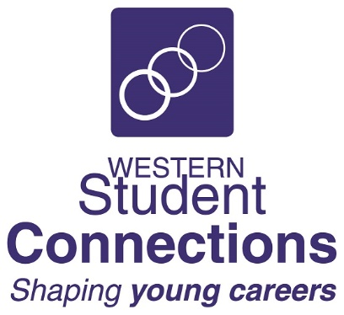
WESTERN STUDENT CONNECTIONS
SOUTH WEST SYDNEY BE REAL GAME PROJECT
2023

EMAIL TO: reception@wsc.edu.au

EXPRESSION OF INTEREST

HALF-DAY STUDENT BE REAL GAME INTRODUCTION

As part of our week-long Be Real Game Experience in south-west Sydney we are offering five schools the opportunity to each have a half-day Be Real Game student workshop.

The workshop will include Unit 1 Sessions 1 - 5:

- Registration on the Be Real Game portal
- Introduction to the Be Real Game
- Allocation of Roles
- Session on key concepts – Skills, personal attributes, job, occupation, career, High Five Principles
- Role History activity
- Group set-up and group activity
- Resume session – guidelines and preparation based on Role History
- Job application – Classifieds, Job Application Form, First Job Profile
- Lifestyle Choices & Budgeting

Each student will need:
- Access to a computer or laptop with internet

Number of students in each school group: 25 – 30 students Years 9 – 11 (more on negotiation)

Venue: In-school - classroom or meeting room

If you would like to have us at your school, please complete the information below and return to Western Student Connections as soon as possible – reception@wsc.edu.au

School Name:
Contact Name: |  |  | Position:
Email Address:
Number of students:
Preferred Timeslot:

Tuesday 7 March 2023 | Morning 9am – 11:45am | Afternoon 12:30pm – 3:15pm
Wednesday 8 March 2023 | Morning 9am – 11:45am | Afternoon 12:30pm – 3:15pm
Thursday 9 March 2023 | Morning 9am – 11:45am | Afternoon 12:30pm – 3:15pm
Friday 10 March 2023 | Morning 9am – 11:45am

