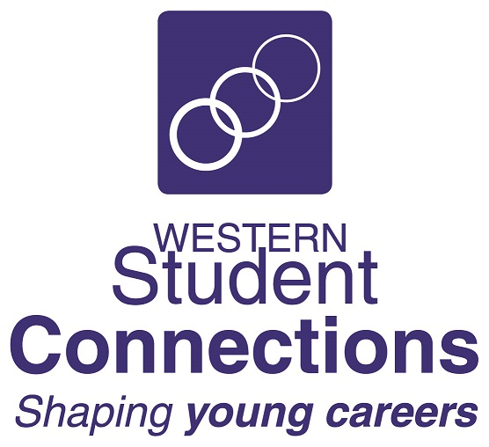
WESTERN STUDENT CONNECTIONS
2022

EMAIL TO: reception@wsc.edu.au

EXPRESSION OF INTEREST

ONE-DAY STUDENT BE REAL GAME WORKSHOP

Western Student Connections Facilitators can come to your school and run a one-day Be Real Game workshop for up to 50 students.

The workshop will include:

- Registration on the Be Real Game portal
- Introduction to the Be Real Game
- Allocation of Roles
- Session on key concepts and career development activities:
  - Role History activity
  - Group set-up and group activities
  - Resume session – guidelines and preparation based on Role History
  - Job application – Classifieds, Job Application Form, First Job Profile
  - Lifestyle Choices & Budgeting
  - Decision-making and problem-solving
  - The Spin Game
  - Job change
  - Transition planning

Each student will need:
- Access to a computer or laptop with internet

Number of students in each school group: up to 50 students Years 9 – 11

Venue: In-school – classroom, large meeting room, hall

If you would like to have us at your school, please complete the information below and return to Western Student Connections as soon as possible – reception@wsc.edu.au

School Name:
Contact Name: |  |  | Position:
Email Address:
Number of students:
Preferred Date:

Preference 1
Preference 2

